Centrifugal Compressor Design

# ME 5427

# Zhaoyi jIang(.1364)

# 04/25/2019

## Introduction

In this report, the design of the centrifugal compressor is discussed. The students use given data and multiple data ranges to find the compressor meets the following requirements. The inducer, impeller and diffuser of the compressor are designed.

Inducer

The air enters the compressor through the inducer. The cross section area of the inducer gets narrower and it accelerates the air goes into the compressor. Using the formula below to calculate the Mach number using speed c1s. w1 represents the relative velocity at the inlet, $γ$ and R are the ideal gas constant and T is the temperature at the inlet. Accounting to the graph of c1s and Mach number, the minimum c1s is around 140m/s and the corresponding Mach number is 0.78. The graph is shown below. Assume its isentropic process.

$$Ma=\frac{w1stip}{\sqrt{γ*R*T}}$$

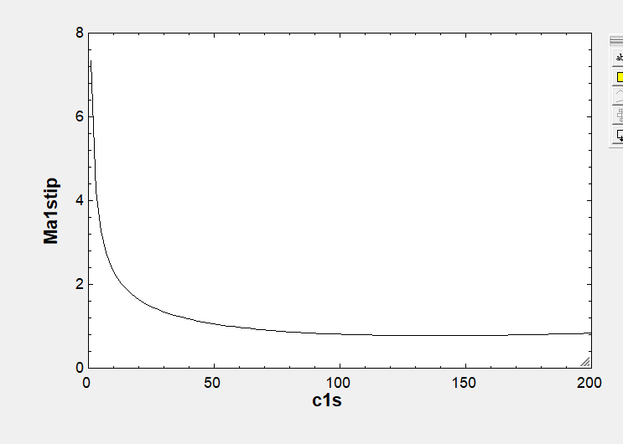

Impeller

The mean radius of the impeller is firstly calculated using the average of tip and hub radius. The inlet blade speed, u1, can be obtain using the RPM and radius. Using the mean radius, the inlet velocity triangle is calculated. Similarly, the outlet velocity triangle is also calculated by using the outlet blade speed, u2, which is obtained by using outlet radius, RPM and total to total efficiency. The equations and velocity triangles are shown below:

$$rm=\frac{rtip+rhub}{2}$$

$$η_{tt}=\frac{h03ss-h0}{ψ*{u2}^{2}}$$

$$r=\frac{30*u}{π*N}$$

The above data are only considering the perfect condition which is not applicable in the real use. The blade and the actual flow angle are not the same due to the pressure difference. The angle of relative speed is a little larger than the flow angle. The blade number is set to be 14 and the slip factor is found to be 0.8483. The corresponding equations are shown below.

$$Blade\#=\frac{cos(\frac{β1-β2b}{2})*2*π}{0.4+ln⁡(\frac{r2}{r1m})}$$

$$slip=1-\frac{\sqrt{cos⁡(β2b)}}{z^{0.7}}$$

Use the following equation to calculate cu2b, and the velocity triangle can be calculated.

$$slip=1-\frac{cu2b-cu2}{u2}$$

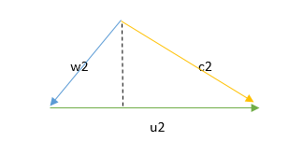

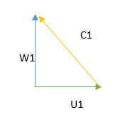

Outlet velocity triangles Inlet velocity triangles

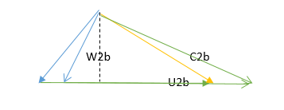

Velocity with slip factor

The new mach number is calculated using the following equation. To make sure the Mach number is below 1, the loading coefficient is changed from 0.7 to 0.85 and the Mach number is 0.9586.

$$Ma=\frac{w1stip}{\sqrt{γ*R*T}}$$

Diffuser

Since there is no geometric for the diffuser, the basic thermal dynamic numbers are calculated. The stage 2 and 1 are calculated in the above steps. After calculated the enthalpy h03 and h3, the c3 is obtained using the equation:

$$h03=h3+\frac{{c3}^{2}}{2}$$

Based on the entropy and enthalpy of stage 3, the pressure and temperature are also obtained. The recovery coefficient of diffuser is calculated using the following equation:

$$Cr=\frac{h3-h2}{h02-h2}$$

Using this equation, we can calculate the thermal dynamics conditions h2.

Work

The work of the diffuser is calculated using the formula below, and the power is the work times the mass flow rate of the compressor.

$$w=ϕ*{u2}^{2}$$

Summary of all data

Theoretical velocity triangles

|  |  |  |  |
| --- | --- | --- | --- |
| C1 | 140 m/s | rm | 0.0199 m |
| C2 | 315.2 m/s | r2 | 0.03126 m |
| W1 | 199.7 m/s | 𝛼1 | 0 degree |
| W2 | 77.47 m/s | 𝛼2 | 79.99 degree |
| U1 | 144.4 m/s | 𝛽1 | 46.33 degree |
| U2 | 365.2m/s | 𝛽2 | -45 degree |

Velocity triangles with slip factor

|  |  |
| --- | --- |
| W2b | 54.79 m/s |
| C2b | 369.9 m/s |
| 𝛽2b | -22.14 degree |
| 𝛼2b | 81.48 degree |

Geometry of compressor

|  |  |  |  |
| --- | --- | --- | --- |
| B3 | 0.01659 m | B2 | 0.006588 m |
| Rtip | 0.0187 m | Blade# | 14 |
| rhub | 0.005289 m | Rm | 0.01199 m |

Pressure and Temperature

|  |  |  |  |
| --- | --- | --- | --- |
| P0 | 1 bar | T0 | 298 k |
| P1 | 0.89 bar | T1 | 288.5 k |
| P2 | 1.81 bar | T2 | 361.3 k |
| P02 | 2.834 bar |  |  |
| P3 | 1.967 bar | T3 | 383.4 k |

Thermal dynamics graph

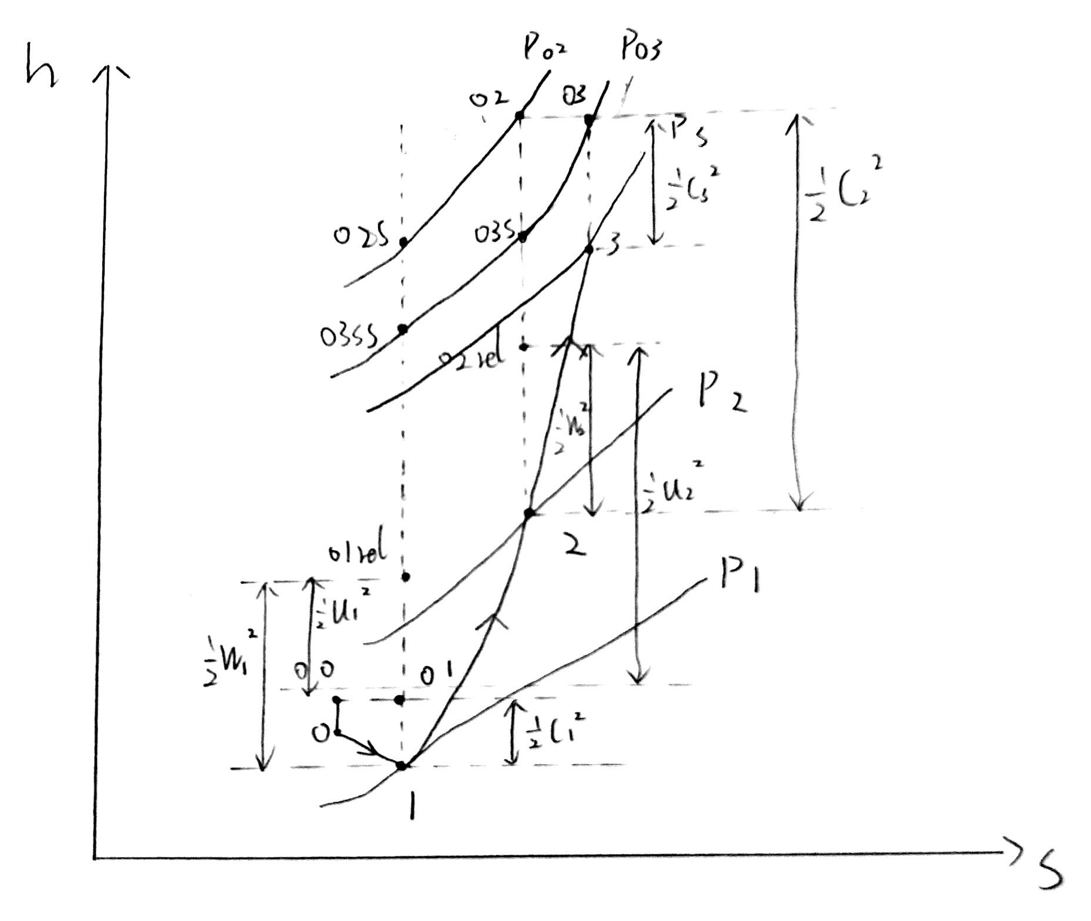

Work and Power

|  |  |
| --- | --- |
| Work | 113.4 KJ/KG |
| Power | 17.01 KW |

EES code

